TEMVIORA WP SUITE
Documentation & User Guide
Theme Security, SEO & Site Intelligence Toolkit
VERSION | AUTHOR | PRODUCT WEBSITE
2.14.6 | ThemeGet | https://themeget.com/

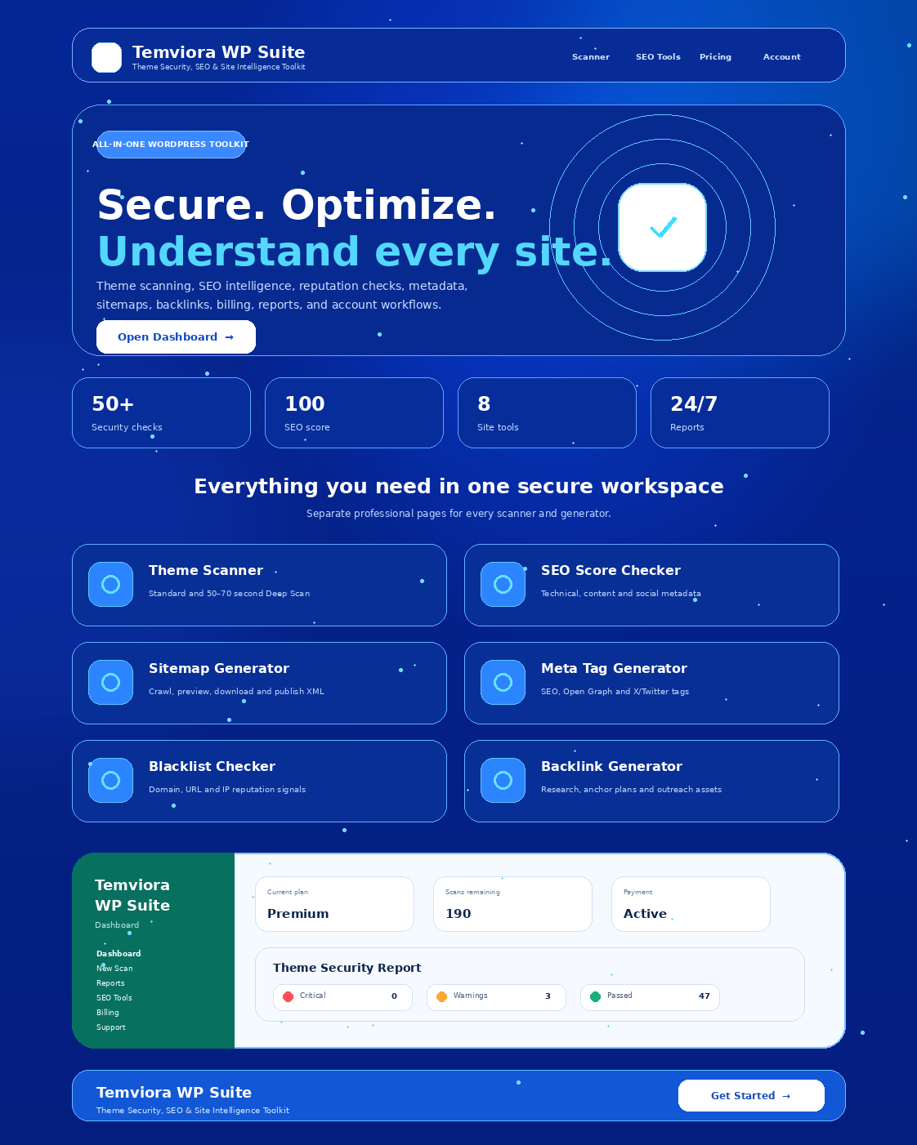
Temviora WP Suite product interface and tool overview
Prepared for installation, administration, customer onboarding, and marketplace distribution.

Document control
Use this guide as the customer-facing documentation included with the commercial theme package.
Item | Value
Product | Temviora WP Suite
Tagline | Theme Security, SEO & Site Intelligence Toolkit
Current documented version | 2.14.6
Author / publisher | ThemeGet
Product website | https://themeget.com/
Theme type | Classic WordPress theme with front-end SaaS-style dashboard
Minimum WordPress version | 6.4
Minimum PHP version | 7.4
Primary language | English; translation-ready text domain: temviora-wp-suite

Important compatibility note
The public product name is Temviora WP Suite. Some internal PHP classes, option keys, asset handles, and legacy routes retain the “taskivoza” prefix to preserve update compatibility. Do not bulk-rename internal identifiers unless you are prepared to migrate saved settings, user metadata, AJAX actions, and URLs.

Contents
- 1. Product overview
- 2. Server requirements and pre-installation checklist
- 3. Installation and activation
- 4. Automatically created pages and navigation
- 5. Accounts, plans, and access control
- 6. Dashboard and tool pages
- 7. WordPress Theme Scanner
- 8. Reports and exports
- 9. XML Sitemap Generator
- 10. Website SEO Score Checker
- 11. Meta Tag Generator
- 12. Blacklist Checker
- 13. Backlink Campaign Generator
- 14. Billing and payment gateways
- 15. SMTP and transactional email
- 16. Support tickets and contact messages
- 17. Advertising widget areas
- 18. Security, privacy, and operational limits
- 19. Mobile and responsive behavior
- 20. Troubleshooting
- 21. Updates, backups, and release checklist
- 22. Legal and marketplace notes
- 23. Support information

1. Product overview
An all-in-one WordPress theme and site-intelligence workspace for developers, agencies, product sellers, and site owners.
Temviora WP Suite combines a commercial landing page, front-end account system, subscription-style dashboard, WordPress theme ZIP scanner, technical SEO tools, sitemap and metadata generators, reputation checks, backlink campaign planning, payments, SMTP email delivery, and customer support workflows in one installable theme.
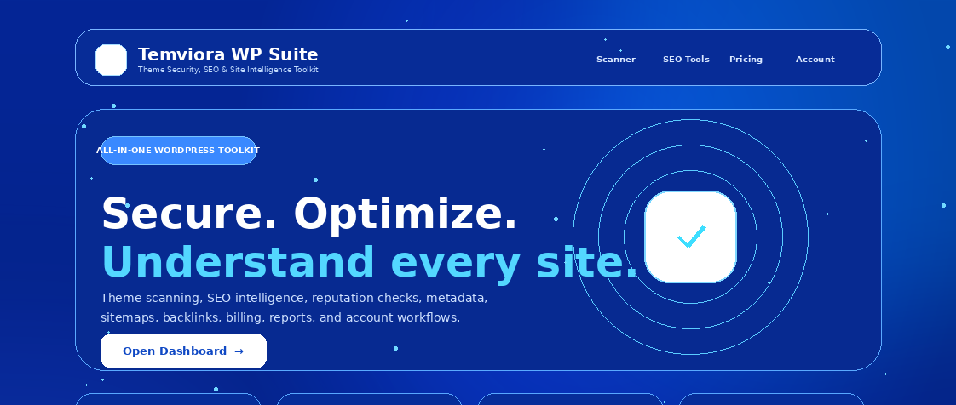
Front-page positioning: security, optimization, and site intelligence

Core capabilities
Module | Purpose
Theme scanning | Standard and Deep Scan modes with severity, evidence, line references, metrics, and downloadable reports.
SEO intelligence | Technical, on-page, content, social metadata, and performance checks with a weighted 0–100 score.
Content discovery | Same-domain XML sitemap crawling, preview, download, and administrator publishing.
Metadata generation | SEO, canonical, robots, Open Graph, and X/Twitter tag generation with previews.
Reputation checks | Domain, URL, and IP risk signals with optional third-party provider integrations.
Campaign planning | Backlink outreach strategies, natural anchor distributions, search operators, and outreach resources.
Commercial workflows | Starter/Premium plan behavior, manual and API payment options, payment status management, and scan allowance controls.
Customer operations | Registration, login, password recovery, verification, SMTP emails, support tickets, and contact messages.

Recommended use cases
- Sell a hosted WordPress theme-audit and SEO toolkit.
- Provide pre-installation theme package reviews for clients or marketplace customers.
- Operate a subscription dashboard with Starter and Premium scan behavior.
- Offer technical SEO, metadata, sitemap, reputation, and outreach planning tools from one branded site.
- Use the theme as a foundation for a commercial WordPress SaaS-style product.

2. Server requirements and pre-installation checklist
Requirement | Minimum / recommendation | Why it matters
WordPress | 6.4 or newer | Required by the distributed theme header and current APIs used by the suite.
PHP | 7.4 or newer | Required for typed code paths and scanner classes.
ZIP reader | ZipArchive recommended; WordPress PclZip fallback supported | Needed to inspect uploaded WordPress theme packages.
Upload size | At least 25 MB | The scanner accepts theme ZIP files up to 25 MB.
Execution time | 150 seconds or more recommended | Deep Scan includes a 50–70 second client-visible processing window plus server analysis.
HTTPS | Strongly recommended | Protects logins, payment callbacks, verification links, and API credentials.
Pretty permalinks | Recommended | The suite creates dedicated public routes for dashboard tools.
Outbound HTTPS | Required for external checks and API gateways | Used by SEO, blacklist, payment, and remote analysis integrations.
SMTP connectivity | Required only when SMTP delivery is enabled | Needed for verification, password reset, payment, and admin notification emails.

Pre-installation checklist
- Create a full database and files backup.
- Confirm the server can upload and extract a 25 MB ZIP package.
- Verify HTTPS and a valid SSL certificate.
- Record the intended administrator email and payment currency.
- Prepare SMTP credentials if account verification or reliable transactional email is required.
- Prepare API credentials only for the external providers you intend to enable.
- Test on a staging site before deploying to production.

3. Installation and activation

Install from WordPress administration
1. Sign in to WordPress as an administrator.
2. Open Appearance → Themes → Add New → Upload Theme.
3. Select the Temviora WP Suite ZIP package.
4. Choose Install Now, then Activate.
5. Visit Settings → Permalinks and click Save Changes once to refresh rewrite rules.
6. Open the home page, /account/, and /dashboard/ to confirm the theme initialized correctly.
Do not upload the documentation ZIP as the theme
Upload the installable theme ZIP whose root contains style.css, functions.php, front-page.php, page-scan.php, and the inc/ and assets/ directories.

What activation creates
On activation—and again during the built-in version migration—the theme creates or repairs the required public pages and assigns the correct page templates. Existing matching pages are reused rather than duplicated.

4. Automatically created pages and navigation
Route | Function | Access
/ | Public product landing page | Public
/account/ | Login, registration, password recovery, verification status, and account summary | Public; account details require login
/contact/ | Public contact form with reference number and admin storage | Public
/dashboard/ | Account overview and quick links | Authenticated
/scan/ | Standard and Deep WordPress theme scanning | Authenticated
/reports/ | Latest and saved scan reports | Authenticated
/sitemap-generator/ | XML sitemap generation and publishing | Authenticated; publishing requires administrator
/seo-score-checker/ | Website SEO analysis | Authenticated
/meta-tag-generator/ | SEO and social metadata generation | Authenticated
/blacklist-checker/ | Domain, URL, and IP reputation checks | Authenticated
/backlink-generator/ | Outreach campaign planning | Authenticated
/billing/ | Plans, payment methods, transaction status, and upgrade flow | Authenticated
/support/ | Help center and support-ticket form | Authenticated
/plan-settings/ | Plan details and account usage | Authenticated

Legacy sitemap route
The published XML sitemap uses the compatibility route /taskivoza-sitemap.xml. This internal route remains unchanged after the public rebrand so existing integrations and saved links continue to work.

Navigation behavior
- Desktop: fixed full-height sidebar with independent scrolling.
- Mobile: off-canvas drawer with touch scrolling, backdrop closing, safe-area padding, and automatic closing after navigation.
- Each major tool is a real WordPress page; tools are not stacked into one long dashboard page.
- The top bar links to documentation/support areas and the signed-in account.

5. Accounts, plans, and access control

Front-end account workflow
- Login with username or email address.
- Create a Starter account from the front-end registration form.
- Recover a password through the native WordPress reset pipeline, routed through the suite email templates when SMTP is configured.
- Optionally require email verification before login.
- Redirect non-administrator customers away from the WordPress back end to the front-end dashboard.

Default plan behavior
Plan state | Default allowance / timing | Result behavior
New Starter account | 20 scans; minimum 20-second Standard Scan screen | The result is held until the 20-second presentation window completes.
Premium-tier account | Allowance configured by payment settings; no artificial Standard Scan delay | The result appears after actual server analysis completes.
Deep Scan for any plan | Uses one scan credit; 50–70 second processing window | Expanded analysis and professional report fields.
Manual override | User meta taskivoza_instant_scans | When enabled, Standard Scan bypasses the artificial delay.

Premium detection recognizes plan names containing Premium, Pro, Professional, Business, Agency, Enterprise, or Unlimited. Administrators should keep plan naming consistent with the payment configuration.

6. Dashboard and tool pages
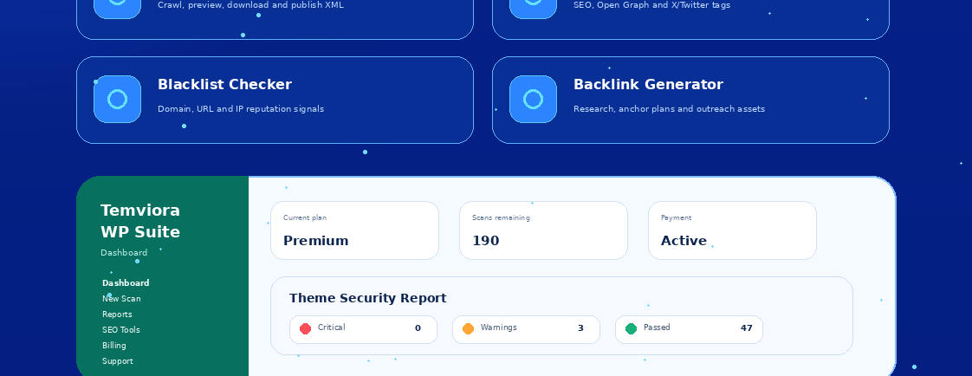
Customer dashboard summary with plan, usage, payment, and security report data
The dashboard is the authenticated control center. It shows plan status, used and remaining scans, payment state, renewal information, recent reports, and direct access to each tool. The interface is responsive and keeps the navigation separate from the main content area.

Recommended administrator onboarding
1. Configure plan names, prices, currencies, and scan allowances.
2. Enable only payment methods that have complete credentials or manual instructions.
3. Configure SMTP and send a test email.
4. Configure external blacklist providers if those results will be offered.
5. Add responsive ad widgets only after testing all dashboard pages on mobile.
6. Create a test Starter user and a test Premium user to verify both timing paths.

7. WordPress Theme Scanner

Supported scan modes
Mode | Typical timing | Best for | Output depth
Standard Scan | Starter: minimum 20 seconds; Premium: actual processing only | Routine package checks and quick customer reports | Structure, security, quality, compatibility, metadata, package findings, metrics, and evidence.
Deep Scan | 50–70 second processing window for all plans | Higher-value audits and detailed review packages | Larger source-read budget, expanded PHP/JS/CSS/SVG/package checks, confidence, attack surface, external hosts, risk-ranked files, and limitations.

Upload rules
- Accepted format: .zip only.
- Maximum package size: 25 MB.
- The archive must contain a valid WordPress theme structure, including style.css at the theme root.
- Uploaded code is inspected from temporary storage; it is not installed or executed.
- The scanner maps archive entries and applies explicit source-read safety limits.
- One completed scan consumes one scan credit.

Analysis coverage
Area | Examples
Archive safety | Path traversal, symbolic links, compression ratios, archive bombs, double extensions, hidden files, backups, nested archives, unsafe binaries.
Theme structure | Classic and block theme structure, style.css metadata, template files, theme.json, and core template hooks.
PHP | Tokens, execution and obfuscation patterns, request handling, nonce, sanitization, escaping, SQL, REST, AJAX, filesystem, redirects, networking, debugging, deprecated APIs.
JavaScript / TypeScript | Execution sinks, DOM injection, postMessage, browser storage, debugging, remote endpoints, and risky patterns.
CSS / markup / data | CSS and preprocessors, HTML, SVG, XML, JSON, Twig, YAML, text files, privacy, performance, and license declarations.
Metrics | Files read, partial reads, coverage, issue density, external domains, code counts, and highest-risk files.

Understanding findings
Field | Meaning
Severity | Critical, High, Medium, Low, or Informational risk classification.
Category | Security, compatibility, quality, secrets, structure, metadata, licensing, or other rule family.
File and line | Location of the evidence when a reliable source position is available.
Excerpt / code context | Relevant source fragment for manual confirmation.
Confidence | Deep Scan estimate of how strongly the evidence matches the rule.
Recommendation | Suggested validation, remediation, or manual-review action.
Coverage / limitations | What was inspected, partially read, skipped, or outside static-analysis scope.

Static analysis is not execution testing
A clean result does not prove that a theme is secure, legally compliant, or free from runtime defects. High-risk packages should be reviewed by a qualified developer and tested in an isolated staging environment.

8. Reports and exports
- Severity summary and overall status.
- Searchable finding list with severity filters.
- File structure and package metadata.
- Line-level evidence and source excerpts where available.
- Scan coverage, archive engine, file counts, and timing.
- Copyable summary, print support, and downloadable JSON report.
- Latest report access from the separate Reports page.
Report JSON is suitable for archiving, customer delivery, internal review, or importing into a separate reporting workflow. It should not be treated as a formal penetration-test certificate or copyright clearance.

9. XML Sitemap Generator
The sitemap tool crawls a public website from a starting URL, follows same-domain HTML links, and produces standards-compatible XML that can be previewed, copied, downloaded, or published by an administrator.
Capability | Behavior
Crawl limit | Up to 100 same-domain public HTML pages.
Filtering | Excludes private/local targets, admin and login paths, checkout flows, feeds, and non-HTML assets.
Options | Optional image records and query-string URL inclusion; common tracking parameters are removed.
Output | URL count, crawled count, skipped count, duration, XML preview, copy, and download.
Publishing | Administrators can publish a sitemap for the current WordPress host at /taskivoza-sitemap.xml.
robots.txt | The published route is added to the WordPress robots.txt output.

Publishing restriction
Publish only a sitemap generated for the current WordPress host. External-site sitemaps should be downloaded and installed on the target site through its own administration or hosting environment.

10. Website SEO Score Checker
The SEO checker performs server-side analysis of a public HTML page and calculates a weighted 0–100 score. It groups results into Technical, On-page, Content, Social, and Performance categories.

Checks include
- HTTP status, HTTPS, redirects, indexability, canonical URL, viewport, language, and charset.
- robots.txt and XML sitemap discovery.
- Title, meta description, headings, structured data, image alt attributes, internal and external links.
- Text quantity and text-to-HTML signals.
- Open Graph and X/Twitter metadata.
- Response time, HTML size, scripts, stylesheets, and mixed content.
Results include passed checks, warnings, failed checks, category scores, recommendations, downloadable JSON, and per-user recent-check history. Private and local network targets are blocked.

11. Meta Tag Generator
The metadata workspace generates copy-ready HTML tags and provides search-result and social-card previews before publishing.
Generated element | Purpose
SEO title and description | Primary search-result metadata with character guidance.
Canonical URL | Declares the preferred page URL.
Robots directives | Controls indexing and link-following preferences.
Open Graph | Social title, description, image, URL, site name, type, and locale.
X/Twitter Card | Card type, title, description, image, and optional account fields.
Supporting metadata | Author, optional keywords, language/locale, and browser theme color.

- Import existing public metadata from a URL.
- Review quality score and specific field recommendations.
- Copy the generated tags.
- Download an HTML file.
- Restore recent generated sets from per-user history.

12. Blacklist Checker
The reputation checker accepts a public domain, URL, IPv4 address, or IPv6 address and combines local security heuristics with optional external provider results.
Provider / signal | Configuration
Google Safe Browsing | API key under Tools → Blacklist Checker. Confirm the provider licence is suitable for the product’s commercial use.
VirusTotal API v3 | API key; the tool requests existing domain or IP reports and must respect provider rate limits.
URLhaus | Auth-Key for known malware-distribution URL checks.
Spamhaus DNSBL | Optional low-volume DNSBL queries; commercial/high-volume use may require a suitable paid service.
Local signals | DNS, HTTPS/HTTP, punycode, suspicious hostname terms, embedded credentials, unusual ports, and hostname complexity.

Results include a 0–100 risk score, confirmed listings, suspicious results, provider errors, unconfigured-provider notices, a network snapshot, caching, force refresh, history, and JSON export.

13. Backlink Campaign Generator
The Backlink Generator is a campaign-planning tool. It reviews a public target page and prepares research and outreach resources; it does not auto-submit, buy, exchange, or publish backlinks.

Generated campaign assets
- Campaign-readiness score.
- Natural anchor-text distribution for the selected placement target.
- Balanced authority, guest contribution, resource-page, broken-link, digital PR, or local-citation strategy.
- Opportunity roadmap and prospect search operators.
- Linkable content ideas.
- Customizable outreach email templates.
- Optional prospect-domain review queue and qualification checklist.
- JSON and CSV downloads plus campaign history.
Quality requirement
Every prospect must be reviewed manually for relevance, editorial quality, traffic authenticity, legal compliance, and search-engine guidelines.

14. Billing and payment gateways
The suite supports API-based and manual payment methods with configurable routing. Methods are hidden from customers until the required credentials or manual account instructions are saved.
Category | Supported methods
Bangladesh / regional | SSLCOMMERZ API, bKash manual, Nagad manual, Rocket manual, and bank transfer.
International API / bridge | Stripe, PayPal, Binance Pay, Razorpay, Worldpay HPP, Amazon Pay bridge, 2Checkout, and Payoneer Checkout bridge.
Manual fallback | Manual instructions can be configured per supported provider and approved by an administrator.
Switching modes | Automatic routing, customer choice, Bangladesh only, international only, API only, or manual only.

Administrator setup
1. Open Temviora WP Suite Payments in WordPress administration.
2. Choose the gateway switching mode and billing currencies.
3. Set plan prices, scan allowances, and Premium activation rules.
4. Enable API and/or manual mode for each provider.
5. Enter required credentials or manual account instructions.
6. Configure Stripe webhooks and SSLCOMMERZ IPN/validation URLs shown by the settings page.
7. For Amazon Pay and Payoneer, configure a merchant bridge endpoint returning a checkout_url or provide a supported checkout template.
8. Test every enabled method in sandbox/test mode before production.

Transaction behavior
- Server-side verification is implemented for SSLCOMMERZ, Stripe, PayPal, Binance Pay, and Razorpay.
- Worldpay, Amazon Pay bridge, 2Checkout, and Payoneer may require administrator review unless the merchant integration verifies and activates the order separately.
- Manual payments collect transfer details and optional proof for administrator approval or rejection.
- Approved or verified Premium payments activate instant Standard Scan results.
- API credentials and merchant accounts are not included in the theme package.

15. SMTP and transactional email
Open Settings → Temviora WP Suite SMTP to configure authenticated email delivery. The system integrates with WordPress mail and provides branded HTML templates, test-email diagnostics, notification routing, and delivery logs that do not store message bodies.
Email event | Recipient / purpose
Password reset | Customer receives the native reset link in the suite’s branded template.
Account verification | Optional signed verification link with expiry and resend support.
Welcome message | Customer onboarding after registration or verification.
Payment status | Pending, approved, failed, or rejected notifications to customers.
Administrator alerts | New accounts, payments, support tickets, and contact messages according to enabled switches.
Test email | Validates SMTP settings and records a diagnostic result.

SMTP configuration checklist
- Enable SMTP only after entering a valid host, port, encryption mode, username, and password.
- Set a From address that the SMTP provider permits.
- Use TLS or SSL according to the provider’s documented port.
- Keep certificate verification enabled in production.
- Send a test email and inspect the delivery log before enabling mandatory verification.
- Add all administrator notification recipients.
- Confirm password reset, verification, payment, support, and contact emails using test accounts.
Credential security
SMTP passwords are stored using Sodium secretbox or OpenSSL AES-256-GCM when available. Treat the WordPress database, salts, and administrator accounts as sensitive and restrict access accordingly.

16. Support tickets and contact messages
Channel | User experience | Administrator location
Help & Support | Signed-in user selects a category, subject, and message and receives a unique ticket reference. | Support Tickets
Contact page | Guest or signed-in visitor submits a public enquiry and receives a unique reference. | Contact Messages
Email delivery | SMTP notification to administrators and optional customer confirmation. | Settings → Temviora WP Suite SMTP

Tickets and messages are saved in WordPress even when email delivery fails. This prevents SMTP problems from discarding customer submissions. Rate limiting, nonces, server-side validation, and honeypot fields are used to reduce abuse.

17. Advertising widget areas
Six responsive dashboard advertising regions can be configured from Appearance → Widgets using Custom HTML, an ad-network widget, or a house advertisement.
Widget area | Placement
Dashboard Ad — After Theme Scanner | Below the scanner section.
Dashboard Ad — After Sitemap Generator | Below the sitemap tool.
Dashboard Ad — After SEO Checker | Below the SEO checker.
Dashboard Ad — After Meta Tag Generator | Below the metadata tool.
Dashboard Ad — After Blacklist Checker | Below the reputation checker.
Dashboard Ad — After Backlink Generator | Below the campaign planner.

Recommended formats are responsive code or 970×90, 728×90, and 320×100 creatives. Confirm that advertisements do not block navigation, forms, mobile scrolling, or report controls.

18. Security, privacy, and operational limits

Built-in controls
- Nonce validation for state-changing front-end requests.
- Capability checks for administrator-only settings and publishing.
- Input sanitization and output escaping across public forms.
- Private/local network blocking for remote analysis tools.
- Rate limiting for authentication, support, contact, and analysis endpoints.
- Output buffering and normalized JSON responses to reduce corruption by notices or plugin output.
- Temporary handling of uploaded theme archives without installation or execution.
- API keys remain server-side and are not intentionally exposed to the browser.

Data handled by the suite
Data | Typical storage / handling
User accounts | Native WordPress users plus plan, scan allowance, and verification metadata.
Scan reports | Returned to the user and latest report/history data according to the theme workflow.
Payment transactions | WordPress options/custom records and gateway callback data required for status management.
Support/contact submissions | Private WordPress custom post types with reference and status metadata.
SMTP logs | Delivery metadata and error diagnostics; message bodies are not stored in the delivery log.
API credentials | WordPress options; access restricted to administrators.

Production responsibility
The site operator is responsible for privacy notices, consent, retention periods, payment-provider terms, data-protection compliance, security hardening, backups, and incident response.

19. Mobile and responsive behavior
- The dashboard sidebar becomes an off-canvas drawer on small screens.
- The drawer has its own touch-scroll container and larger tap targets.
- Backdrop tap, close button, Escape key, route selection, and orientation changes close or resize the drawer.
- Page scrolling is locked only while the drawer is open.
- Scan progress is inline in the report panel, not a full-screen popup.
- The supplied animated loading GIF should remain active for the full upload and scan lifecycle.
- Forms and result panels stack vertically on narrow screens.
Cache after upgrades
When a mobile fix or loader update appears unchanged, purge the browser cache, WordPress cache, optimization/minification cache, and CDN cache. The theme uses versioned assets, but some cache layers may still retain old files.

20. Troubleshooting
Problem | Recommended action
Dashboard page returns 404 | Open Settings → Permalinks and click Save Changes. Confirm the page exists and uses the Temviora dashboard template.
Required pages are missing | Reactivate the theme or load the site as an administrator so the version migration can recreate pages.
Scanner engine unavailable | Enable PHP ZipArchive or ensure the WordPress PclZip file is readable.
ZIP rejected | Use a valid .zip under 25 MB with style.css in the theme root. Remove nested package wrappers if necessary.
Deep Scan times out | Raise max_execution_time and proxy timeouts; confirm the host permits requests longer than 70 seconds.
Invalid JSON / invalid response | Clear caches, disable aggressive HTML/JS optimization for dashboard routes, inspect PHP logs, and confirm admin-ajax.php is reachable.
Mobile sidebar does not click or scroll | Purge cached CSS/JS, disable conflicting page-builder overlays, and confirm the current theme version is active.
Loading GIF stops early | Clear image/CDN cache and confirm the animated GIF in the active theme assets was not re-optimized into a static image.
SMTP test fails | Check host, port, encryption, credentials, From address permissions, DNS, and outbound SMTP restrictions.
Verification email not received | Check spam, delivery logs, SMTP test, and administrator notification settings; resend verification.
Payment remains pending | Verify webhook/IPN URLs, signing secrets, sandbox/live mode, callback accessibility, and manual approval queue.
Gateway is not visible | Complete its required credentials or manual account instructions and enable the corresponding mode.
Blacklist provider unavailable | Add its API key under Tools → Blacklist Checker and confirm provider limits/terms.
Support/contact form succeeds but no email arrives | Open Support Tickets or Contact Messages; the submission may be saved even if SMTP delivery failed.

21. Updates, backups, and release checklist

Before updating
- Back up the database and wp-content directory.
- Export or record payment, SMTP, and blacklist-provider settings.
- Test the new ZIP on staging.
- Keep the same theme folder when performing an in-place update so WordPress recognizes it as the same product.
- Do not rename legacy internal prefixes unless a migration is included.

After updating
1. Clear all caches and regenerate minified assets.
2. Save permalinks.
3. Confirm each separate dashboard route.
4. Run one Starter Standard Scan, one Premium Standard Scan, and one Deep Scan.
5. Test account registration, login, reset, and optional verification.
6. Send an SMTP test email.
7. Test each enabled payment method in sandbox or low-risk mode.
8. Submit a support ticket and a contact message.
9. Test the mobile sidebar and scan loader on iOS and Android-sized viewports.

Marketplace package checklist
- Installable theme ZIP only.
- This DOCX documentation file.
- Plain-text or HTML documentation copy if required by the marketplace.
- Product screenshots and promotional images created for Temviora WP Suite.
- Licensing information for any included third-party libraries or assets.
- Changelog and version number.
- Support URL and response policy.
- Demo URL with test credentials only if safe and permitted.

22. Legal and marketplace notes
Copyright and trademark distinction
Copyright protects original creative works and source code; product names and brand identifiers are mainly trademark concerns. The seller should perform a current trademark and domain check before launch and should not imply affiliation with WordPress, payment providers, search engines, or security-data providers.

- “WordPress” is used descriptively to explain compatibility; the product brand is Temviora WP Suite.
- Payment-provider, search-engine, API-provider, and social-platform names remain the property of their respective owners.
- Do not include API keys, merchant credentials, SMTP passwords, customer data, or private test reports in the distributed ZIP.
- Review the licence and commercial-use terms for every API or data provider before enabling it in a paid service.
- Automated scan output is advisory and is not a legal determination of copyright ownership, licensing compliance, vulnerability absence, or marketplace acceptance.
- The seller should include a privacy policy, terms of service, refund policy, acceptable-use policy, and security disclaimer appropriate to the target market.

Suggested product disclaimer
Temviora WP Suite provides automated static analysis and website intelligence signals. Results may contain false positives or false negatives and do not constitute a security certification, legal opinion, copyright clearance, search-ranking guarantee, or endorsement by any third-party platform. Review important findings manually and test changes in a controlled environment.

23. Support information
Resource | Details
Author / publisher | ThemeGet
Product website | https://themeget.com/
Customer support | Use the product website or the support channel supplied with the marketplace listing.
In-product support | Authenticated users can open /support/ and submit a ticket.
Public contact | Visitors can open /contact/ and submit an enquiry.
Recommended support request details | WordPress version, PHP version, theme version, affected route, browser/device, steps to reproduce, screenshot, and relevant error-log excerpt without credentials.

Temviora WP Suite
Theme Security, SEO & Site Intelligence Toolkit
https://themeget.com/
Documentation version 2.14.6

