RENTIVOZA
Rental Property & House Booking WordPress Theme
Complete Installation, Configuration & User Guide
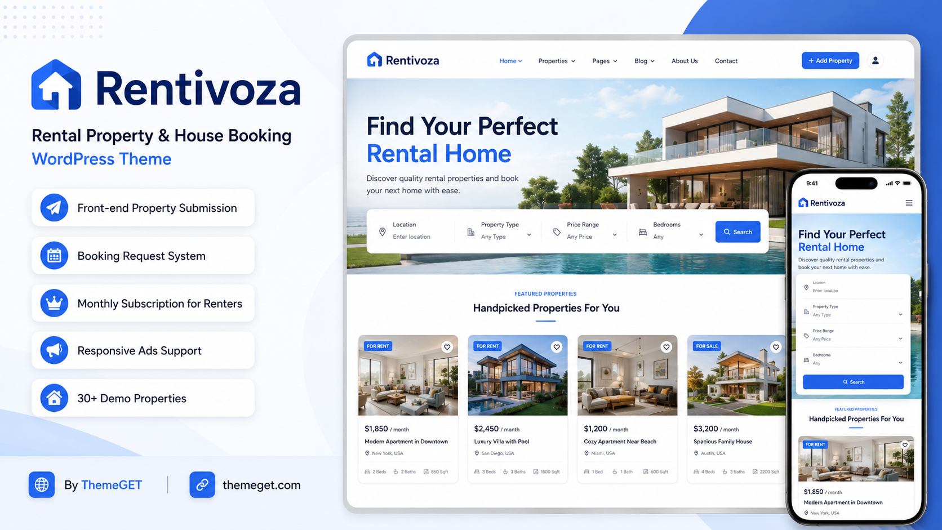
VERSION  1.8.0 | AUTHOR  ThemeGET | RELEASED  28 July 2026
WORDPRESS  6.4 or newer | PHP  7.4 or newer | LICENSE  GPL v2 or later
Product and support: themeget.com

1. Welcome to Rentivoza
  - This guide is prepared for buyers, site administrators, property owners, renters, and marketplace reviewers.
Rentivoza is a light, responsive WordPress theme for house-rental directories, apartment listings, property-owner submissions, renter booking requests, monthly booking subscriptions, and administrator-managed advertisements.
Important platform scope
Rentivoza can charge users for monthly booking-access subscriptions. It does not collect house rent, security deposits, or owner-to-renter payments. Those transactions are completed directly outside the website.

What is included
- Front-end registration, login, password reset, and account dashboard.
- Front-end rental submission, editing, deletion, featured-image upload, and gallery upload.
- Rental archive, property-type taxonomy, location and price filters, and detailed property pages.
- Booking requests with move-in date, lease duration, occupants, renter message, and status tracking.
- Monthly Renter and Renter Plus booking subscriptions using manual approval or optional Stripe Checkout.
- Administrator-managed responsive image banners and trusted HTML, iframe, or JavaScript advertisements.
- Thirty realistic demo rental listings, locally bundled photographs, SVG icons, and 420 animation presets.

Documentation conventions
Format | Meaning
WordPress Admin → Menu → Screen | A navigation path inside the WordPress dashboard.
Button or field name | The exact label shown by the theme.
Note / Important / Security | Operational guidance that should be reviewed before launch.

2. Documentation Map
Use this section as a quick index. Each chapter is written in setup order, followed by daily administration and troubleshooting.
Section | Topic
3 | Requirements and package contents
4 | Installation and activation
5 | Automatic pages and navigation
6 | Homepage and visual customization
7 | Demo rentals
8 | User accounts and authentication
9 | Property submission and management
10 | Rental search and property pages
11 | Booking request workflow
12 | Monthly renter subscriptions
13 | Manual payment approval
14 | Optional Stripe setup
15 | Responsive advertisement system
16 | Administrator operations
17 | Updates and migration
18 | Translation, accessibility, and performance
19 | Troubleshooting
20 | Security, legal scope, and credits

Recommended launch sequence
Install → activate → verify generated pages → configure Customizer → review demo rentals → configure booking plans → create advertisements → test registration, listing submission, and booking from a separate user account.

3. Requirements and Package Contents

Minimum environment
Component | Requirement
WordPress | 6.4 or newer
PHP | 7.4 or newer
Browser | A current desktop or mobile browser
Permalinks | Any normal WordPress permalink structure; activation refreshes rewrite rules
HTTPS | Strongly recommended; required for production Stripe Checkout
Email delivery | WordPress mail or an SMTP plugin/service for reliable notifications

Theme package
- `rentivoza-wordpress-theme-v1.8.0.zip` — installable WordPress theme package.
- Local CSS and JavaScript files, including responsive-ad handling and animation presets.
- Local SVG icons and the Font Awesome Free license notice.
- Local demonstration property, city, map, and hero photographs with source credits.
- Thirty duplicate-safe demo rentals and an import/remove control.
Do not unzip before dashboard upload
When installing through WordPress, upload the complete theme ZIP. WordPress will extract the `rentivoza` folder automatically.

4. Installation and Activation

Install through WordPress Admin
1. Sign in to WordPress as an administrator.
2. Open Appearance → Themes → Add New Theme → Upload Theme.
3. Choose `rentivoza-wordpress-theme-v1.8.0.zip` and select Install Now.
4. After installation completes, select Activate.
5. Open the WordPress dashboard once and review the activation notices.

Manual installation
1. Extract the ZIP on your computer.
2. Upload the `rentivoza` folder to `/wp-content/themes/` using your hosting file manager or SFTP.
3. Open Appearance → Themes and activate Rentivoza.

What activation changes
Action | Result
Creates pages | Home, Login, Register, Submit Rental, My Dashboard, and Booking Plans.
Sets homepage | The generated Home page becomes the static front page.
Enables accounts | WordPress user registration is enabled and the default role is Subscriber.
Creates property types | Apartment, House, Room, Studio, and Office.
Creates menu | Rentivoza Primary with Home, Browse Rentals, Post a Rental, and Booking Plans.
Imports demo data | Thirty demo rentals are imported once unless demo auto-import was previously disabled.
Refreshes URLs | WordPress rewrite rules are flushed for rental archive and property URLs.

After activation
Open Settings → Permalinks and select Save Changes once if rental URLs return a 404 error.

5. Automatic Pages and Navigation

Generated pages
Page | Default slug | Template / purpose
Home | /home/ | Static homepage using the theme front-page layout.
Login | /login/ | Front-end login form.
Register | /register/ | Front-end account registration.
Submit Rental | /submit-rental/ | Create or edit a rental listing.
My Dashboard | /my-dashboard/ | Listings, subscriptions, booking requests, and account actions.
Booking Plans | /membership-plans/ | Free Browse, Renter, and Renter Plus plans.
Rental Archive | /rentals/ | Searchable published rental results; generated by the rental post type.

Menu management
1. Open Appearance → Menus.
2. Select the Rentivoza Primary menu.
3. Add, remove, rename, or reorder items.
4. Confirm the menu is assigned to the Primary location, then save.
Do not delete functional pages casually
The theme resolves account and submission URLs by page slug. If a page is replaced, keep the expected slug or assign the matching Rentivoza page template.

6. Homepage and Visual Customization
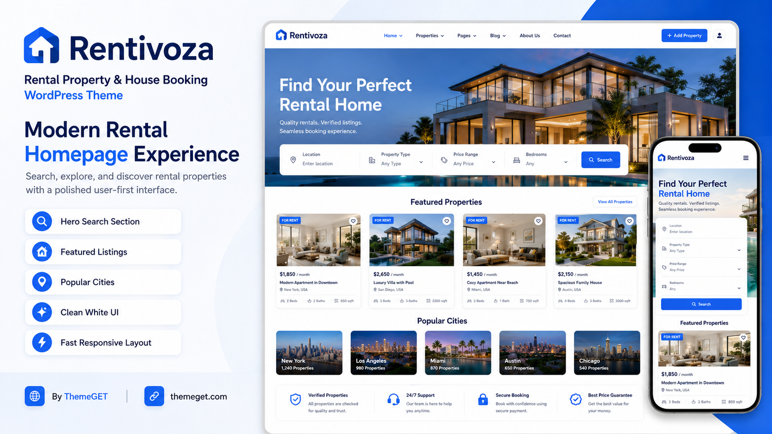
Rentivoza homepage and mobile search presentation.

Customizer options
Open Appearance → Customize → Rentivoza Options.
Control | Purpose
Currency symbol | Controls the price symbol used by rental listings.
Auto-publish front-end rentals | Publishes user listings immediately when enabled; otherwise sends them for review.
Homepage hero image | Replaces the bundled hero photograph. Use a bright landscape image with the building toward the right.
Homepage hero title | Controls the main homepage heading.
Homepage hero text | Controls the supporting hero description.

Branding and logo
- Use Appearance → Customize → Site Identity to upload a custom logo and change the site title.
- Use a transparent PNG or SVG-compatible logo plugin when a scalable custom logo is required.
- The footer includes a linked “By ThemeGET” credit pointing to `http://themeget.com/`.
Image guidance
For best results, use landscape property photos with clean lighting. Avoid watermarks, visible third-party trademarks, and images that you do not have permission to publish.

7. Thirty Demo Rentals
Rentivoza includes a duplicate-safe demonstration dataset to make the homepage and rental archive usable immediately after activation.

Manage the dataset
Open Rentals → Demo Rentals.
Action | Effect
Import or repair 30 demo rentals | Creates missing demo listings and leaves existing demo listings in place.
Remove demo rentals | Deletes only listings marked internally as Rentivoza demo content.

Demo content includes
- Realistic titles, descriptions, prices, cities, areas, and property types.
- Bedrooms, bathrooms, size, furnished status, amenities, contact information, and map links.
- Featured images and gallery images using locally bundled demonstration photographs.
- Published status and internal demo markers to prevent duplicates or accidental removal of user content.
Marketplace safety
Demo addresses, prices, contacts, and listing details are fictional examples. Replace or remove them before launching a real rental marketplace.

8. User Accounts and Authentication

Registration fields
Field | Rule
First name / Last name | Optional.
Username | Required and must be unique.
Email address | Required, valid, and unique.
Password | Required; minimum 8 characters.
Confirm password | Must match the password.
Site-rules checkbox | Required before account creation.

Login and password recovery
- Users can sign in with a username or email address.
- The Remember me option uses the standard WordPress authentication cookie.
- Forgot password links to the standard WordPress password-reset workflow.
- Logged-in visitors opening Login or Register are redirected to My Dashboard.
Email delivery
Account and booking notifications depend on the server’s WordPress mail configuration. Configure SMTP when messages do not arrive reliably.

9. Property Submission and Management

Owner workflow
1. Register or log in.
2. Open Post a Rental or My Dashboard → Add rental.
3. Complete property, location, pricing, room, amenity, photo, and contact fields.
4. Submit the listing.
5. If moderation is enabled, wait for an administrator to publish the pending listing.
6. Use My Dashboard to view, edit, or move the listing to Trash.

Submission fields
Group | Fields
Basic details | Title, description, property type.
Location | Street address, area/neighborhood, city, external map URL.
Pricing and rooms | Price, day/week/month billing period, bedrooms, bathrooms, square feet, furnished status.
Amenities | Theme-defined amenity checkboxes such as Wi-Fi, parking, air conditioning, and others.
Photos | One main property image and gallery images.
Contact | Phone number and contact email.

Image limits
- Accepted formats: JPG, PNG, and WebP.
- Maximum file size: 5 MB per image.
- The main image appears on property cards.
- The current plans use a gallery limit of six images.
Ownership protection
A user can edit only their own rental unless the account has permission to edit other users’ posts. Submission and deletion actions use WordPress nonces and ownership checks.

10. Rental Search and Property Pages

Search filters
- Keyword or location text.
- Minimum and maximum monthly price.
- Property type.
- Bedrooms.

Single-property information
- Featured image and image gallery.
- Monthly, weekly, or daily price.
- Address, area, city, and property type.
- Bedrooms, bathrooms, size, furnished status, and amenities.
- Owner contact information and external map link.
- Booking-request form when the renter has an eligible active plan.
Search-result visibility
Only published rentals are visible publicly. Pending and draft listings remain visible to their owners inside My Dashboard.

11. Booking Request Workflow
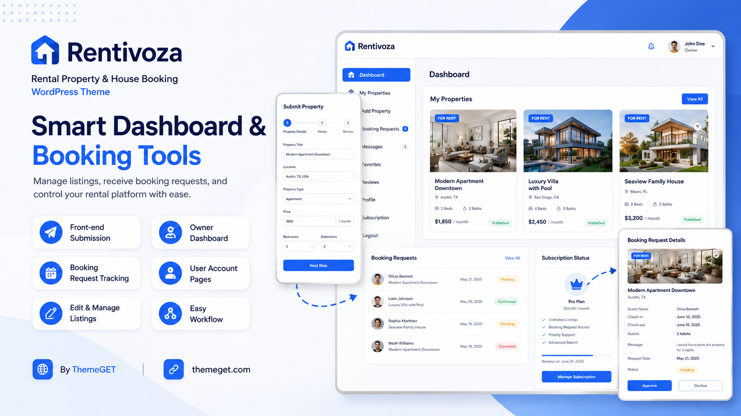
Owner dashboard, property submission, and booking-request management.

Renter steps
1. Create an account and activate a booking plan.
2. Open a published property.
3. Choose a move-in date and lease duration.
4. Enter the number of occupants and a message to the owner.
5. Submit the request and track its status from My Dashboard.
6. Cancel a request while it is still pending when necessary.

Owner steps
1. Open My Dashboard.
2. Review incoming booking details for owned properties.
3. Approve, reject, or mark the request completed.
4. Contact the renter directly for verification, documents, deposits, and final rental arrangements.

Booking status model
Status | Meaning
Pending | Submitted and waiting for owner action.
Approved | Accepted by the owner for further coordination.
Rejected | Declined by the owner.
Completed | Marked complete after the external rental process.
Canceled | Canceled by the renter where permitted.

A booking is not a lease
A theme booking request is an inquiry and workflow record. Administrators should publish clear terms explaining identity checks, contracts, deposits, refunds, and local rental law.

12. Monthly Renter Subscriptions

Default plans
Plan | Default price | Booking access
Free Browse | $0/month | Browse listings; no booking requests.
Renter | $9.99/month | Up to 5 booking requests per calendar month.
Renter Plus | $19.99/month | Unlimited booking requests per calendar month.

Administrators can change the currency code, currency symbol, and both paid-plan prices under Rentivoza System → Settings.

Monthly usage
- Renter usage resets each calendar month.
- Renter Plus displays unlimited allowance.
- Subscription status and expiry are shown in My Dashboard.
- Users can cancel automatic renewal for Stripe-backed subscriptions; access continues until the current period ends.
Subscription purpose
The paid plan unlocks booking-request capacity. It does not include rent collection, property deposits, escrow, or payouts to owners.

13. Manual Subscription Payment and Approval

Configuration
1. Open Rentivoza System → Settings.
2. Enable Manual payment.
3. Enter clear bank or mobile-transfer instructions.
4. Set the billing notification email and save changes.

Approval workflow
1. The user chooses Renter or Renter Plus on Booking Plans.
2. The user submits a transaction reference and receipt where requested.
3. Open Rentivoza System → Subscriptions and select the pending record.
4. Check the payment method, reference, and receipt.
5. Set Status to Active.
6. Choose an expiry date or leave it blank to grant or extend access by 30 days.
7. Update the subscription record.

Subscription statuses
Status | Use
Pending payment | A record exists but payment is not ready for review.
Payment review | Receipt/reference is awaiting administrator verification.
Active | Booking plan is granted.
Rejected | Payment or request was declined.
Expired | Access ended.
Canceled | Renewal or membership was canceled.
Past due / Payment error | Automatic payment could not be completed.

Verify before approval
Never approve a manual subscription based only on a screenshot. Confirm the transaction in the actual receiving account and follow your own fraud-prevention process.

14. Optional Stripe Checkout Setup
Rentivoza can create Stripe Checkout sessions directly without requiring a third-party WordPress payment plugin. Stripe configuration is optional.

Configuration steps
1. Create or use a Stripe account and complete the required business verification.
2. Enable HTTPS on the WordPress website.
3. Open Rentivoza System → Settings and enable Stripe Checkout.
4. Enter the Stripe secret key.
5. Copy the Webhook URL shown by Rentivoza.
6. Create a Stripe webhook endpoint using that URL.
7. Subscribe the endpoint to checkout.session.completed, invoice.paid, customer.subscription.updated, and customer.subscription.deleted.
8. Paste the Stripe webhook signing secret into Rentivoza and save.
9. Test the complete checkout and renewal workflow using Stripe test mode before using live keys.
Protect secret keys
Stripe secret keys and webhook secrets are sensitive credentials. Restrict administrator access, use HTTPS, and never place secrets in public documentation, screenshots, or support messages.

15. Responsive Advertisement System
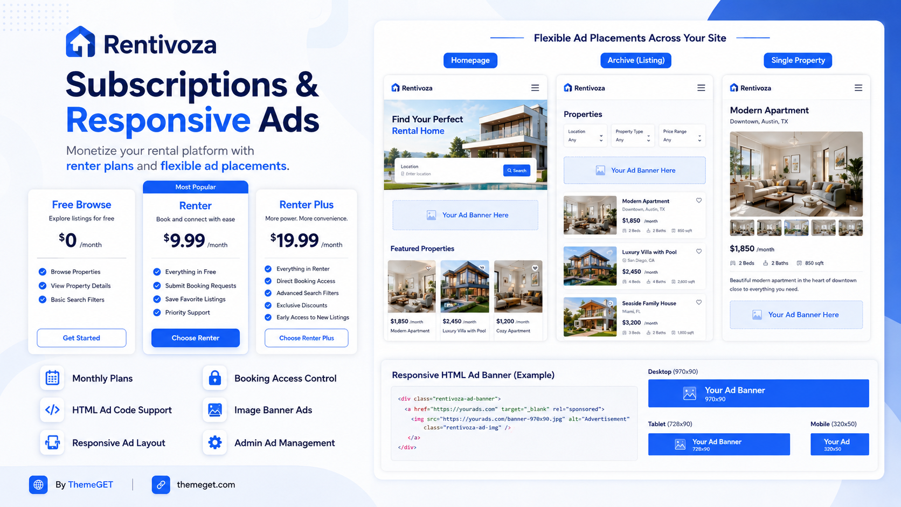
Subscription plans and responsive advertisement placements.

Available placements
Placement | Location | Recommended image size
Homepage Top Banner | Below the homepage trust row. | 1400 × 220 px
Homepage Middle Banner | Between major homepage property sections. | 1400 × 220 px
Rental Results Banner | Above rental search results. | 1400 × 220 px
Property Page Banner | Near the bottom of individual property pages. | 1400 × 220 px

Create an image banner
1. Open Rentivoza System → Advertisements → Add New.
2. Enter an internal advertisement title.
3. Choose Image banner.
4. Set the banner through the Featured Image panel.
5. Enter the destination URL.
6. Choose placement, start date, end date, and optional Sponsored label.
7. Set Status to Active or Scheduled, publish, and verify the selected page.

Create an HTML or JavaScript advertisement
1. Choose HTML / JavaScript ad code.
2. Paste trusted responsive ad-network code, iframe code, or custom HTML.
3. Choose placement, dates, status, and Sponsored label.
4. Publish and test at desktop, tablet, and mobile widths.
<a href="https://example.com/" target="_blank" rel="sponsored noopener">
<img src="https://example.com/banner.jpg" alt="Advertisement">
</a>

Responsive behavior
- Image advertisements preserve aspect ratio and shrink within the page container.
- Fixed-size iframe and HTML creatives are proportionally scaled on smaller screens.
- Responsive provider code remains full width.
- Resize and DOM observers handle advertisements that load after the initial page render.
- Containers prevent horizontal page overflow and keep full left/right banner content visible.
Trusted administrators only
JavaScript and iframe code should be pasted only by a trusted administrator. WordPress accounts without `unfiltered_html` may have unsafe tags removed; on Multisite, full ad-network code normally requires a Super Admin.

16. Administrator Operations

Rental review
- Open Rentals → All Rentals to review pending submissions.
- Use the Rental Details meta box to edit price, address, city, rooms, size, contact, map URL, billing period, and furnished status.
- Publish accurate listings or return questionable content to Draft/Pending.
- Use Property Types to create or reorganize listing categories.

Advertisement monitoring
- The Advertisements list shows type, placement, amount metadata, status, and views/clicks.
- Theme click tracking applies to image banners; HTML providers normally track their own clicks.
- Expired or inactive advertisements are not rendered publicly.

Routine launch checks
Check | Recommended frequency
Pending rental submissions | Daily
Booking disputes or spam | Daily
Manual subscription payments | Daily when enabled
Expired advertisements | Weekly
Theme, WordPress, and plugin updates | Weekly
Backups and security logs | According to hosting policy

17. Updates and Legacy Migration

Safe update procedure
1. Create a complete database and `wp-content` backup.
2. Record any direct code edits; direct theme-file changes can be overwritten.
3. Upload and activate the new Rentivoza package.
4. Open the dashboard and verify pages, menu assignments, Customizer options, subscriptions, ads, and demo content.
5. Clear page, object, CDN, and browser caches.

Migration from the previous Rentora branding
Version 1.8.0 includes a one-time migration that copies previous Customizer values, menu assignments, custom logo data, monetization settings, booking schema state, demo importer state, subscription user metadata, Stripe identifiers, and demo-post markers into Rentivoza identifiers. It also renames the generated primary menu when possible.
Folder rename
Rentivoza uses the `rentivoza` theme folder. Confirm that Rentivoza is the active theme after upload and that the previous theme folder is not accidentally reactivated.

18. Translation, Accessibility, and Performance

Translation
- Text domain: `rentivoza`.
- User-facing strings use WordPress translation functions.
- Create translation files with a standard WordPress localization tool and place them in an appropriate language directory.
- After translating, clear caches and recheck form validation messages, buttons, and responsive layouts.

Accessibility
- Keyboard focus states are included for interactive controls.
- Navigation supports mobile controls and Escape-key closing.
- Animation styles respect reduced-motion preferences.
- Site owners should add meaningful alternative text to uploaded property and advertisement images.
- Use clear labels, sufficient color contrast, and descriptive link text when editing content.

Performance
- Images and SVG icons are stored locally to avoid unnecessary third-party UI dependencies.
- Compress property photos before upload and use WebP where appropriate.
- Avoid loading several heavy ad-network scripts in the same placement.
- Use caching only after testing registration, dashboard, booking, Stripe webhook, and ad tracking exclusions.
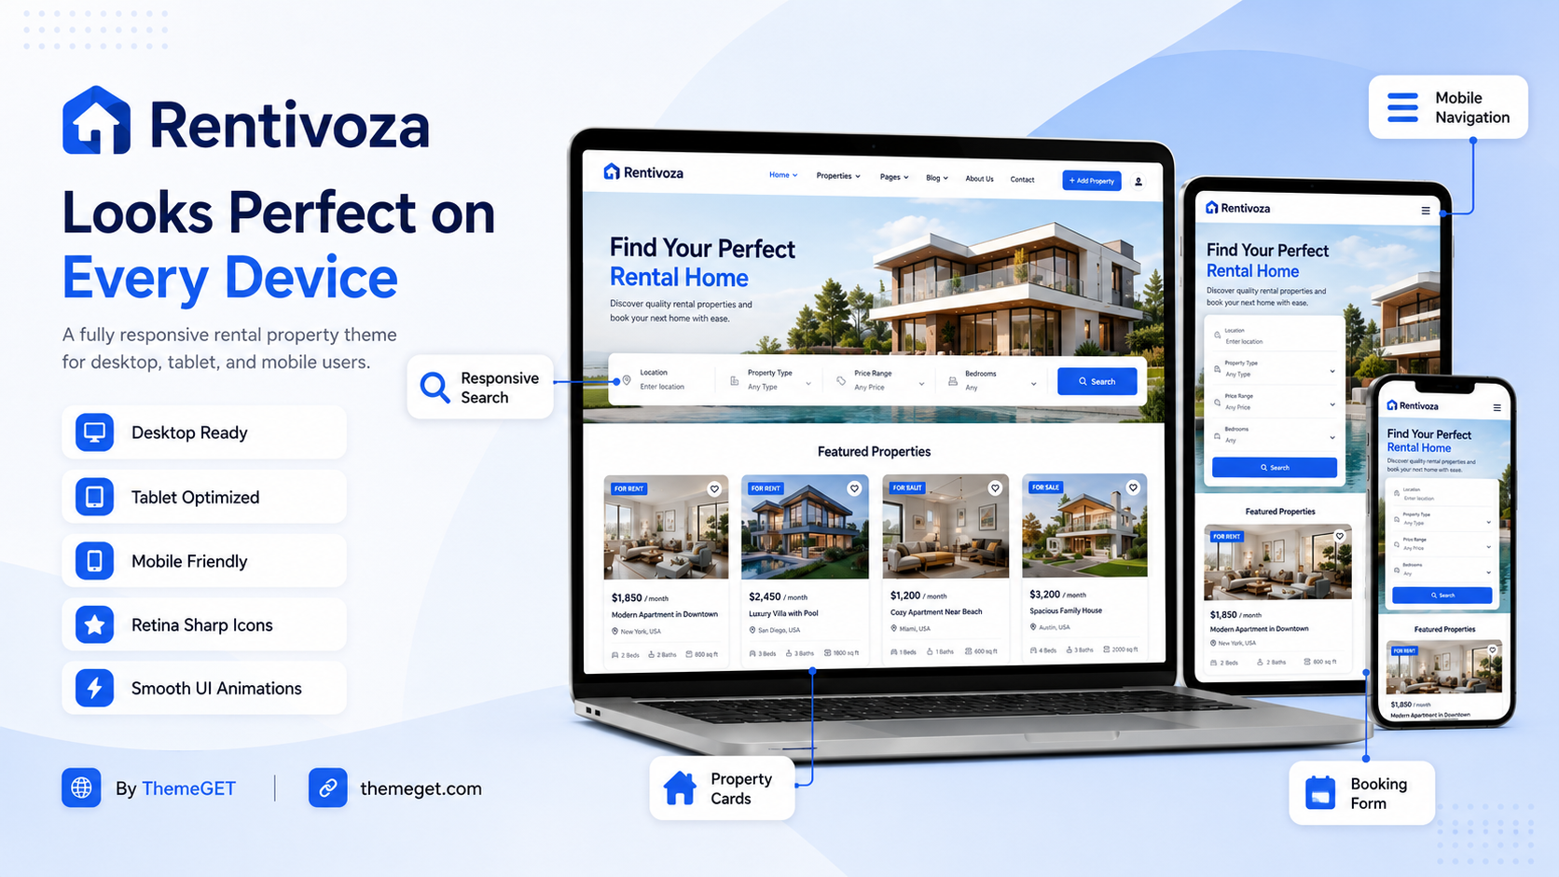
Responsive desktop, tablet, and mobile presentation.

19. Troubleshooting
Problem | Resolution
Critical error during registration | Check the WordPress recovery email and `wp-content/debug.log`; disable conflicting registration/security plugins temporarily; confirm PHP 7.4+ and update to the latest Rentivoza build.
Rental pages return 404 | Open Settings → Permalinks and save once; confirm the theme is active.
Generated page is missing | Create a page with the expected slug and assign the matching Rentivoza template.
New listing is not public | Check Rentals → All Rentals for Pending status or enable Auto-publish in the Customizer.
Images fail to upload | Use JPG, PNG, or WebP under 5 MB; check server upload limits and Media Library permissions.
Booking form is unavailable | Confirm the user is logged in, has an active paid plan, has remaining monthly allowance, and is not the property owner.
Manual plan remains inactive | Open the subscription record, verify payment, set Status to Active, and update.
Stripe checkout fails | Check HTTPS, secret key, site outbound requests, webhook secret, and Stripe test/live mode consistency.
HTML ad code is stripped | Use an administrator with `unfiltered_html`; on Multisite use a Super Admin.
Ad causes horizontal overflow | Use v1.6.1+ responsive ad assets; clear caches and avoid provider code that injects a fixed-width parent outside the theme wrapper.
Demo posts appear twice | Use Rentals → Demo Rentals → Import or repair; the current importer is duplicate-safe. Remove old manually copied posts if they lack demo markers.
Email notifications do not arrive | Configure SMTP and confirm the From address, DNS records, spam filtering, and hosting mail restrictions.

Enable WordPress debugging temporarily
define( 'WP_DEBUG', true );
define( 'WP_DEBUG_LOG', true );
define( 'WP_DEBUG_DISPLAY', false );
Disable debugging after diagnosis
Debug logs can contain server paths, email addresses, and other sensitive data. Remove or protect logs before sharing them.

20. Security, Legal Scope, Credits, and Support

Security checklist
- Keep WordPress, Rentivoza, and all plugins updated.
- Use strong administrator passwords and multi-factor authentication where available.
- Limit administrator access and never give ad-code privileges to untrusted users.
- Verify manual payments through the receiving account.
- Back up the database and uploads before updates.
- Use a privacy policy and terms that explain account data, booking requests, advertisements, subscriptions, and external rental transactions.

License and asset credits
Asset | License / source
Rentivoza theme PHP/CSS/JS | GNU General Public License v2 or later.
Bundled SVG icons | Font Awesome Free license notice included in `assets/icons/FONT-AWESOME-LICENSE.txt`.
Bundled demonstration photographs | Unsplash photographs; photographer and source list included in `assets/images/CREDITS.md`.
Demo listing data | Fictional demonstration content created for Rentivoza.

Support information
Theme author: ThemeGET
Website: themeget.com
Theme: Rentivoza v1.8.0
Before requesting support
Include the WordPress version, PHP version, Rentivoza version, the affected page URL, clear reproduction steps, and the exact error text. Remove passwords, API keys, webhook secrets, payment details, and personal renter data.

Pre-launch checklist
Launch check | Launch check | Launch check
☐ Rentivoza is active, permalinks are saved, and generated pages load correctly. | ☐ Primary navigation, hero image, currency, and publication mode are configured. | ☐ Demo listings are removed or clearly replaced with real listings.
☐ Registration, login, password reset, SMTP, and email delivery are tested. | ☐ A test owner can submit, edit, and delete a rental listing. | ☐ A test renter can activate a plan and send a booking request.
☐ Manual payment or Stripe is fully tested before accepting money. | ☐ All advertisement placements are tested on desktop, tablet, and mobile. | ☐ Legal pages, backups, security, caching, and operational policies are ready.

Rentivoza — Find, list, request, and manage rental homes.
Documentation prepared by ThemeGET • themeget.com
Rentivoza marketplace presentation — by ThemeGET.

