CHATRIONIX
Private Messaging & Social Community WordPress Theme
Official Documentation • Version 1.5.5 • by ThemeGet
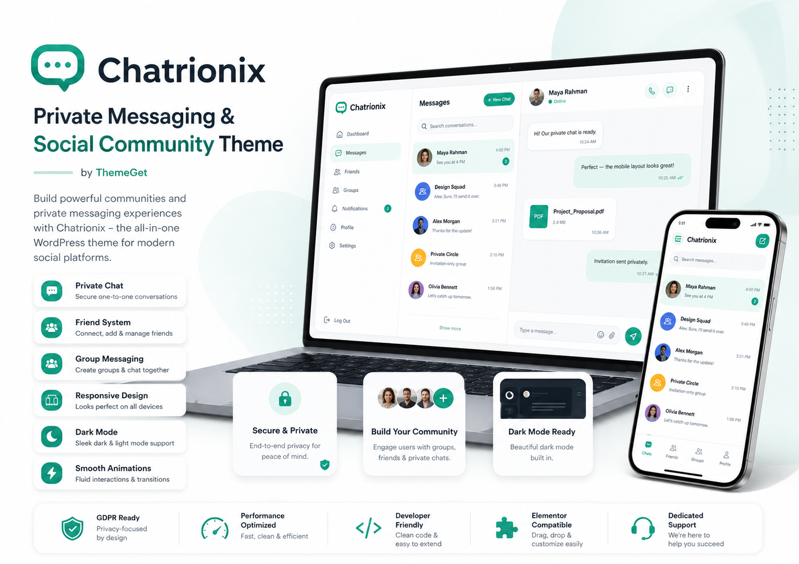
THEME  Chatrionix | VERSION  1.5.5 | LICENSE  GPL v2 or later

Table of Contents
1. Theme Overview..........................................................3
2. System Requirements.....................................................3
3. Installation and Activation.............................................4
4. Initial Site Setup......................................................5
5. Admin Configuration.....................................................6
6. User and Messaging Workflow.............................................9
7. Pages, Menus and Templates..............................................11
8. Appearance and Personalization..........................................12
9. Email, Contact and Password Recovery....................................13
10. Privacy, Security and Moderation.......................................14
11. Performance and Maintenance............................................16
12. Translation and RTL....................................................17
13. Updates and Migration..................................................17
14. Troubleshooting........................................................18
15. Marketplace and Support Notes..........................................20
Purpose This guide is written for site owners, administrators, marketplace buyers and support teams installing the standalone Chatrionix theme package.

1. Theme Overview
Chatrionix by ThemeGet is a standalone WordPress theme for friend-only private messaging and hidden, invitation-only groups. The package includes the user interface, database tables, REST endpoints, authentication pages, privacy tools, moderation controls and administration settings required for a working community website.

Core capabilities
- Friend requests with accept, decline, remove, block and report controls.
- Private one-to-one conversations available only between accepted friends.
- Hidden group conversations where the group owner invites members.
- Text messages, replies, edits, soft deletion, typing indicators, read state and presence.
- Shared emoji reactions and secure file/media uploads.
- Responsive desktop, tablet and mobile layouts with light, dark and system appearance modes.
- Personal chat wallpapers, browser notifications and configurable interface animations.
- Admin statistics, release-readiness checks, retention cleanup and moderation reports.
Important Chatrionix provides access-controlled private messaging. The documentation does not claim end-to-end encryption; transport and hosting security depend on your HTTPS and server configuration.

2. System Requirements
Requirement | Minimum / Recommendation
WordPress | 6.4 or newer
PHP | 7.4 or newer
Database | A WordPress-supported MySQL or MariaDB version
HTTPS | Strongly recommended for secure sessions and browser notifications
Permalinks | Pretty permalinks recommended
BuddyPress | Optional; friendship functions are used when active
Hosting | Suitable PHP memory, upload limits and cron support for the expected community size

3. Installation and Activation

3.1 Install from WordPress
- Sign in to the WordPress administration dashboard.
- Go to Appearance → Themes → Add New → Upload Theme.
- Select chatrionix-1.5.5-by-themeget.zip.
- Click Install Now, then Activate.
- Open the Chatrionix admin menu and review the Release Readiness panel.

3.2 Install by hosting file manager or SFTP
- Extract the ZIP package locally.
- Upload the chatrionix folder to /wp-content/themes/.
- Confirm the final path is /wp-content/themes/chatrionix/style.css.
- Open Appearance → Themes and activate Chatrionix.

3.3 What activation creates
Activation creates the messaging pages and editable information pages. It also creates the theme database tables using the active WordPress site prefix. Switching themes does not automatically delete chat data.
Table | Purpose
chatflow_conversations | Conversation records
chatflow_members | Conversation membership
chatflow_messages | Messages and message state
chatflow_relationships | Friendship/block relationships
chatflow_presence | Online and last-seen presence
chatflow_reactions | Message reactions
chatflow_reports | User reports and moderation queue
chatflow_group_invites | Private-group invitations
chatflow_cleanup_log | Retention cleanup history

4. Initial Site Setup

4.1 Enable registration
For a public community, open Settings → General and enable Membership → Anyone can register. Select an appropriate default role, normally Subscriber. Keep administrator accounts separate from member accounts.

4.2 Configure permalinks
Open Settings → Permalinks and select a readable structure such as Post name. Save once, even when the desired option is already selected, to refresh rewrite rules.

4.3 Review generated pages
Page / Template | Purpose
Chat | Main private messaging application
Login | Branded sign-in page
Register | Frontend account creation
Forgot Password | Password reset request
Reset Password | Reset-key completion page
Account Settings | Profile, privacy and wallpaper preferences
Contact | Public contact form and business details
Privacy Policy | Editable privacy information
Terms & Conditions | Editable terms of use
About / Help / Community pages | Editable public information and guidance

4.4 Create navigation menus
Open Appearance → Menus and assign menus to the available locations: Primary, Footer Product, Footer Company, Footer Resources and Footer Legal. The theme displays fallback links until custom menus are assigned.

5. Admin Configuration
Open Chatrionix in wp-admin. The dashboard begins with live statistics and a Release Readiness card, followed by the settings sections below.

5.1 Website identity and theme
Setting | Use
Website name | Updates the WordPress site title used across the website.
Website tagline | Short public description of the site.
Chatrionix brand name | Brand label shown inside the messaging interface.
Theme color | Primary accent color used throughout the theme.

5.2 Core messaging
Setting | Guidance
Enable Chatrionix | Master switch for messaging features.
Typing indicators | Shows when a participant is composing a message.
Read receipts | Displays message read state.
Message reactions | Allows participants to add synchronized emoji reactions.
Maximum message characters | Allowed range: 100–20,000 characters.
Edit window | Minutes during which a sender can edit a message; 0 can be used according to site policy.
Delete window | Minutes during which a sender can soft-delete a message.

Fixed mode The package uses friend-only direct chats, invite-only private groups and no public rooms.

5.3 Media and notifications
Setting | Guidance
File sharing | Enables attachment uploads in conversations.
Sound alerts | Plays an alert for new activity.
Browser notifications | Uses browser notification permission; HTTPS is recommended.
Unread count in tab title | Adds unread count to the browser tab title.
Maximum upload | 1–100 MB, additionally limited by PHP/hosting limits.
Allowed extensions | Comma-separated allow-list. Executable and active-content formats remain rejected.

5.4 Performance, presence and appearance
Setting | Guidance
Live updates | Requests, invitations, conversations and messages refresh about once per second.
Messages per request | 10–100 messages per request.
Presence timeout | 30–900 seconds before a member is treated as inactive.
Default appearance | Light, Dark or System.
Show last seen | Displays member last-seen information.
Interface animations | Enables interface motion while respecting operating-system reduced-motion preferences.

5.5 Personalization and recovery
Enable Personal chat backgrounds to let members upload private JPG, PNG or WEBP wallpapers from Account Settings. Set the maximum wallpaper size between 1 and 50 MB. Enable Frontend password reset to use the branded recovery workflow.

5.6 Retention and cleanup
Setting | Guidance
Retain messages | Number of days before eligible messages expire. Use 0 to keep indefinitely.
Cleanup frequency | Daily or weekly scheduled cleanup.
Delete attached media | Removes media connected to expired messages.
Run cleanup now | Executes maintenance manually from the admin screen.

6. User and Messaging Workflow

6.1 Friend discovery and requests
- A member searches by username or email. The interface does not expose the searched email address.
- The member sends a friend request.
- The recipient accepts or declines the request.
- After acceptance, both members appear in each other’s Chats section.
- Direct conversation access is validated on the server.

6.2 Private direct chat
Direct messages require an accepted friendship. Members can send text, reply to messages, add reactions and—within the configured windows—edit or delete their own messages. Typing, presence and read-state features depend on the relevant admin switches.

6.3 Private group workflow
- A member creates a private group and becomes its owner.
- The owner sends invitations to selected members.
- The group remains hidden from an invited member until the invitation is accepted.
- Only accepted members can view or participate in the group conversation.
- The owner controls invitations; groups are not publicly discoverable.

6.4 Files and media
Uploads are validated by extension, detected MIME type, nonce, conversation membership and configured size limits. The user interface intentionally hides uploaded filenames in chat bubbles, previews, progress messages and file cards.

6.5 Blocking and reporting
Members can block users and report content or behavior. Reports appear in the Chatrionix administration area under Open reports, where an administrator can review and resolve them.

7. Pages, Menus and Templates
Template file | Recommended page
page-templates/chat.php | Chat
page-templates/login.php | Login
page-templates/register.php | Register
page-templates/forgot-password.php | Forgot Password
page-templates/reset-password.php | Reset Password
page-templates/account-settings.php | Account Settings
page-templates/contact.php | Contact

Do not rename template files inside the theme unless you also update every internal reference. Page titles and body content for public information pages can be edited through the normal WordPress editor.

8. Appearance and Personalization

8.1 Branding
Set the website name, tagline, Chatrionix brand name and accent color from the Chatrionix admin page. Use Appearance → Customize or the Site Editor for standard WordPress identity options supported by the installation.

8.2 Light, dark and system modes
Administrators select the default mode. Members can use the available appearance control where provided. The system option follows the visitor’s operating-system preference.

8.3 Wallpapers
The package contains responsive light/dark conversation wallpapers for desktop and mobile. When personal wallpapers are enabled, each member can upload a private JPG, PNG or WEBP background and restore the default set from Account Settings.

8.4 Animations
The homepage contains 520 motion presets plus interface animation rules. Motion is viewport-based and should run one preset at a time. The theme respects reduced-motion preferences. For slower devices, keep animations enabled but avoid adding third-party animation libraries that target the same elements.
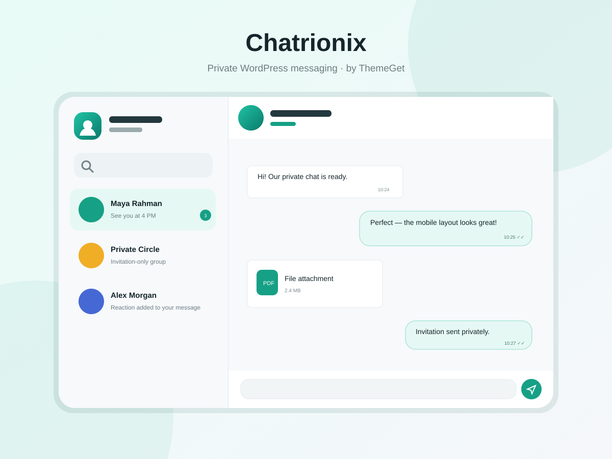
Theme preview included with Chatrionix 1.5.5

9. Email, Contact and Password Recovery

9.1 Contact page
Configure the private form recipient, public email, phone number, WhatsApp number or URL, business hours, address, heading and introduction. The public form includes nonce validation, a honeypot, length checks and rate limiting.

9.2 SMTP configuration
Field | Typical value / note
Enable SMTP delivery | Turn on after entering and saving valid mail-provider details.
SMTP host | Example: smtp.example.com
Port | Commonly 465 for SSL or 587 for TLS; confirm with the provider.
Encryption | None, SSL or TLS
Authentication | Normally enabled for hosted mail accounts.
Username | Usually the full mailbox address.
Password | Saved securely by WordPress options; the existing value is never displayed.
From email / From name | Sender identity used for contact and recovery messages.

Save the settings first, then use Email delivery test. A successful test confirms that WordPress accepted the mail request; final inbox delivery can still depend on DNS, SPF, DKIM, DMARC and provider policy.

9.3 Password recovery
The branded forgot-password and reset-password pages use standard WordPress reset keys. Request responses are non-enumerating, so the page does not reveal whether a submitted account exists.

10. Privacy, Security and Moderation

10.1 Application protections
- Authenticated REST requests require a valid WordPress session and REST nonce.
- Server-side membership checks protect private conversations and hidden groups.
- Mutation endpoints use per-user rate limits.
- Upload handling rejects executable and active-content formats and verifies MIME types.
- Public user payloads do not expose email addresses.
- Contact submissions are nonce-protected, honeypot-screened and rate-limited.

10.2 WordPress privacy tools
Chatrionix registers personal-data exporters and erasers with WordPress. Administrators can use Tools → Export Personal Data and Tools → Erase Personal Data for supported message and account records.

10.3 Legal pages
The theme creates editable Privacy Policy, Terms & Conditions and community guidance content. These are templates, not jurisdiction-specific legal advice. Review them with a qualified professional before publishing.

10.4 Security operations
- Use HTTPS for the entire site.
- Keep WordPress, PHP, plugins and the theme updated.
- Use strong administrator passwords and two-factor authentication where available.
- Restrict administrator access and maintain off-site backups.
- Review Open reports and failed mail or cleanup events regularly.
- Do not advertise end-to-end encryption unless an independently verified encryption layer has been implemented.

11. Performance and Maintenance
The built-in one-second polling model is appropriate for small and moderate communities on capable hosting. Large concurrent audiences may require a companion service using WebSockets or a managed real-time transport.

Recommended actions
- Exclude active chat REST responses from full-page and CDN caching.
- Use object caching only after testing conversation permissions and freshness.
- Set upload and retention limits according to storage capacity.
- Ensure WordPress cron runs reliably for scheduled cleanup.
- Monitor PHP workers, database load, REST latency and storage growth.
- After theme updates, clear page, object, CDN and browser caches.

Backup scope
Back up both the WordPress database and wp-content/uploads. The database contains conversation records; uploaded media and member wallpapers are stored in the media library.

12. Translation and RTL
The theme uses the chatrionix text domain and includes languages/chatrionix.pot plus rtl.css. Create translations with a WordPress-compatible translation tool, compile the required .po/.mo files and test all login, account, chat and admin screens. Rebuild translation files after changing interface strings.

13. Updates and Migration

Safe update procedure
- Create a complete database and files backup.
- Test the new package on a staging copy.
- Review the changelog and any database changes.
- Replace the theme through WordPress or upload the new folder without changing the folder name.
- Activate if required, open Chatrionix and review Release Readiness.
- Clear all caches and test login, registration, chat, uploads, SMTP and cleanup.
Compatibility The package retains legacy chatflow database table and option identifiers so existing data and settings remain compatible after the Chatrionix rebrand.

14. Troubleshooting
Problem | Checks / Resolution
Theme upload fails | Confirm the ZIP contains the chatrionix folder directly and the server upload limit is large enough.
404 on generated pages | Save Settings → Permalinks to refresh rewrite rules.
Registration unavailable | Enable Settings → General → Anyone can register and confirm the Register page exists.
Friend not visible in Chats | Confirm the request was accepted, refresh both sessions and exclude chat endpoints from caching.
Messages do not refresh | Check browser console, REST API access, nonce/session validity, security plugins and server logs.
Uploads fail | Compare theme maximum, PHP upload_max_filesize/post_max_size, allowed extensions and MIME type.
Browser notifications fail | Use HTTPS, grant browser permission and verify notification settings.
Email test fails | Recheck host, port, encryption, authentication, username, password and sender address.
Animations stutter | Clear caches, disable conflicting animation/minification plugins and test without browser extensions.
Cleanup does not run | Verify WP-Cron or server cron and run the manual cleanup button for diagnosis.
Dark mode looks cached | Purge optimization/CDN caches and remove stale combined CSS.
Critical error after activation | Enable WordPress debug logging on staging and verify PHP 7.4+, memory and file integrity.

Diagnostic information for support
- WordPress and PHP versions
- Chatrionix version
- Active plugins and caching/CDN services
- Browser and device
- Exact steps to reproduce
- Relevant WordPress/PHP error-log excerpt with private data removed

15. Marketplace and Support Notes

Distribution boundary
Chatrionix is distributed as a standalone theme and intentionally includes database, REST, authentication, cleanup and privacy functionality. Some theme directories classify these as plugin territory and may require a companion plugin before approval. Review the target marketplace rules before submission.

Licensing and assets
The theme is licensed under GNU General Public License v2 or later. The package states that its inline SVG icons were created for Chatrionix and that emoji are rendered as Unicode by the visitor’s operating system. Use only original or properly licensed screenshots, photos, fonts and promotional assets in your marketplace listing.

Support information
Developer: ThemeGet
Website: themeget.com
When delivering the theme to customers, include the installable ZIP, this documentation, the GPL license, changelog and a clear support/update policy.

Launch Checklist
☐ Activate on a clean staging site and confirm no red Release Readiness items.
☐ Test registration, login, logout, password reset and account settings.
☐ Test friend requests, acceptance, direct chat, blocking and reporting with two accounts.
☐ Test group creation, invitation acceptance/decline and hidden visibility with three accounts.
☐ Test replies, edits, deletions, reactions, typing, read state and presence.
☐ Test every allowed attachment type and verify filenames remain hidden in the UI.
☐ Test personal wallpaper upload/removal in desktop/mobile and light/dark modes.
☐ Send an SMTP test and submit the public contact form.
☐ Review legal pages, contact details, menus, branding and footer links.
☐ Test Chrome, Firefox, Safari, Edge, Android, iOS, keyboard navigation, RTL and reduced motion.
☐ Confirm backups, retention policy, scheduled cleanup, privacy export/erasure and HTTPS.

